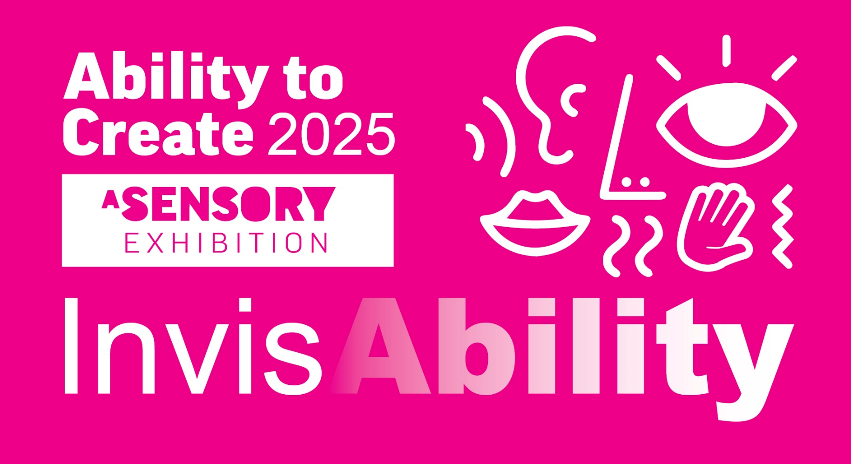
EXPRESSION
OF INTEREST

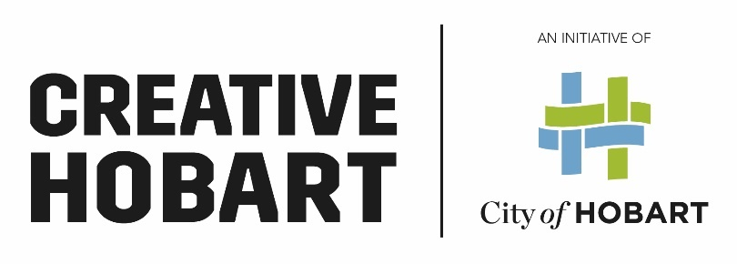
EXPRESSION OF INTEREST
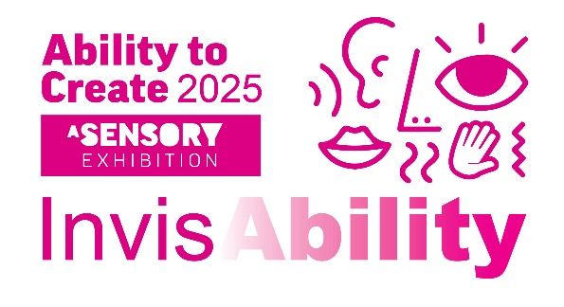

EXPRESSION OF INTEREST APPLICATION FORM

Please refer to the project briefing document to support this application form.
APPLICANT DETAILS
NAME:

STREET ADDRESS:

POSTAL ADDRESS:

PHONE:

MOBILE:

EMAIL:

AUSTRALIAN BUSINESS NUMBER:

SELECTION CRITERIA
Please select which art form best reflects your skills for this interactive InvisAbility exhibition:
Lighting/Sound and/or Digital Content (film, photography, lighting and sound design, animation, recordings, soundscaping).
Visual Arts (painting, sculptural construction, set/prop design to create a large central installation and sensory exhibition space for people to move freely and explore).
Performance – (dance/music/spoken word/theatre/storytelling/performance art to help guide a performative program

Mentor artists will also be required to facilitate several community engagement workshops with the all ability artists with assistance of CoH staff.

- PROPOSAL FOR THE INVISABILITY EXHIBITION
In line with the Project Brief describe how you would approach the theme and apply it to this program given your own arts practice. Include how you would make this project accessible, Inclusive, large scale and safe.

- WORKSHOP ACTIVITIES PROPOSAL
A large part of this program is engagement with Ability to Create artists, support staff,
City of Hobart staff and the wider community through workshop activities. What potential creative workshops ideas do you propose around the InvisAbility theme and how do you foresee engaging with the other mentor artists through this process?

- CAPACITY TO DELIVER
Provide an overview of relevant skills, experience and/or qualifications to successfully execute the project. Please provide any details in regards to availability to complete the project within the timeframe as set out in the Project Brief.

- CV
Please attach Curriculum Vitae (no longer than two A4 page per artist).

- PORTFOLIO
Provide images/films/text/sound files of up to three recent projects/artworks which show your experience and capacity to complete this project.
A.

Project

Date/s
Client
Link
Description:

PORTFOLIO Continued….
Provide images/films/text/sound files of up to three recent projects/artworks which show your experience and capacity to complete this project.
B.

ProjectDate/sClient

Link
Description:

C.

ProjectDate/sClient

Link
Description:

- WORKING WITH VULNERABLE PEOPLE (WWVP)

Do you have a current Working With Vulnerable People (WWVP) card?
Yes Card No. No

If successful, I will obtain a WWVP card before commencement of the project.

EOI CHECKLIST
Applicant details Selection criteria
- Proposal 2. Capacity to deliver 3. Workshop Activity

4. CV 5. Portfolio 6. WWVP

Please ensure you sign the EOI Form before submitting it to:
Sue Hayes at hayess@hobartcity.com.au
by 3pm Friday 9 August 2024

Signature

Upon signing this form, the Artist acknowledges having read and agreed to the project terms as stated in the Project Brief.
Name

Date

