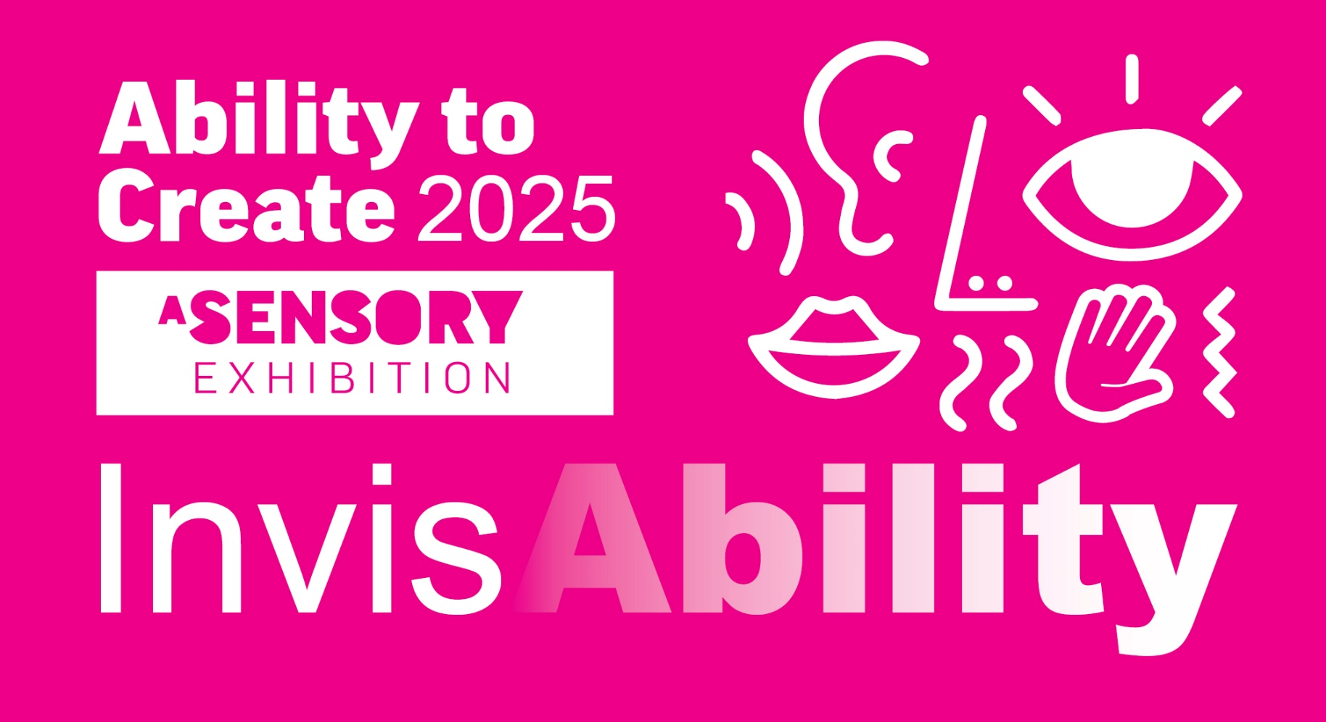
PROJECT
BRIEF

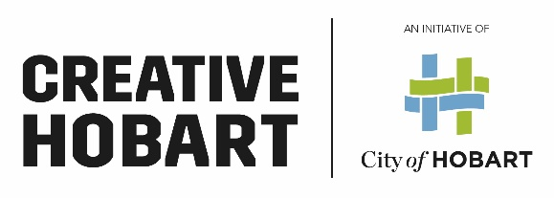
PROJECT BRIEF

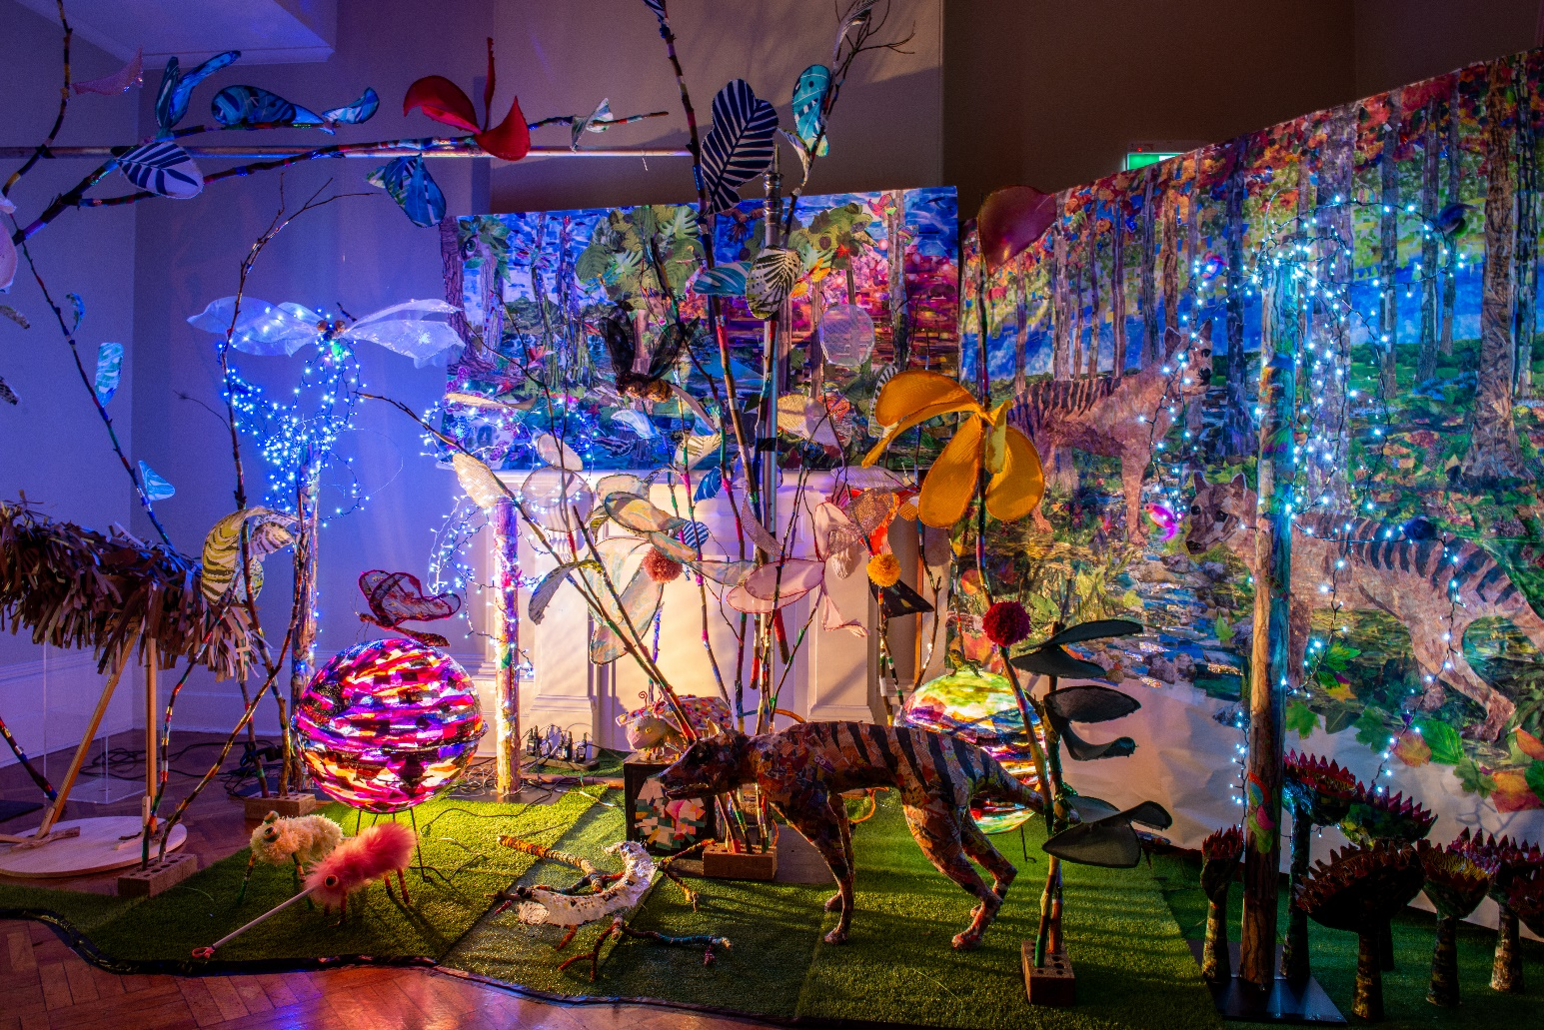

Image Credit: Langford Support Services de-extinction world ATC 2023. Image by Paul County

EXHIBITION BACKGROUND
Ability to Create (ATC) started in 2014 with an eclectic exhibition of art pieces made by clients of local disability organisations. The project has evolved considerably since then, with greater collaboration with all ability artists and relevant support organisations.
The exhibition is held in Town Hall, in the Ballroom and adjacent rooms, to accommodate all the artists and their diverse art forms, performances and to provide greater accessibility.
This year the City of Hobart has received support through Arts Tasmania’s Industry Development program to deliver Ability to Create. We will engage three mentor artists to work with and support the Ability to Create artists with Second Echo Ensemble (SEE) as the lead mentor organization.

Image Credit: Alex Moss in the Lamp Forest, ATC 2022 Image by Rebecca Thomson

ORGANISATIONS INVOLVED IN ABILITY TO CREATE

SECOND ECHO ENSEMBLE (SEE)

www.secondechoensemble.org

ABLE AUSTRALIA

www.ableaustralia.org.au/
MOSAIC SUPPORT SERVICES (MSS)
www.mosaictas.org.au
THE PARKSIDE FOUNDATION
www.parksidefoundation.org.au
LIFE WITHOUT BARRIERS (LWB)
www.lwb.org.au
LANGFORD SUPPORT SERVICES (LSS)
www.langford.org.au
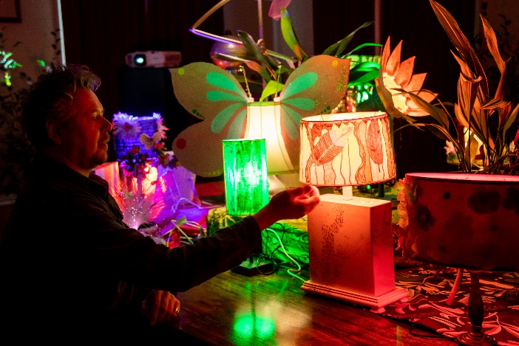

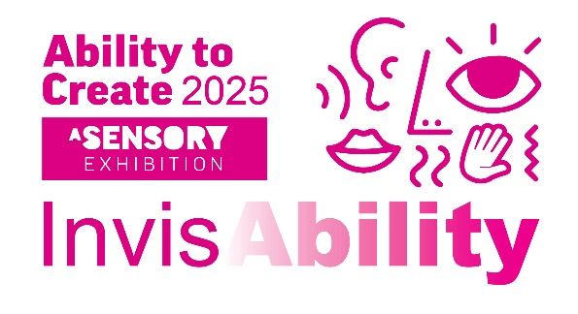

WHAT WE ARE LOOKING FOR
We are looking for three arts practitioners with skills in either:
- Lighting/Sound and/or Digital design
- Visual arts
- Performance (Dance/Music/Text/Theatre, Storytelling)

(or a hybrid of these above disciplines).

The selected artists will work with ATC artists and organisations to co-create infrastructure and artworks for the launch of the Ability to Create 2025 INVISABILITY exhibition program.

The finalised art works need to have the capacity to be adapted to large scale, engaging all ability artists where possible in a collaborative installation and encouraging interactivity and accessibility for all.

*This activity takes place in Nipaluna/Hobart and therefore is best suited to artists who have been residing in Tasmania for at least 6 months.
THEME
INVISABILITY: Making the invisible visible
INVISABILITY considers both people and place in Hobart by:
- Making artists visible
- Removing stigma and bias around hidden disability
- Increasing community understanding
of the term ‘disability’ to include
people who identify as neuro-divergent
or have other unseen disabilities.
- Second Echo Ensemble (SEE) Creative Director Kelly Drummond Cawthon and core ensemble members will kick off the project with artist mentor workshops and offer support throughout the project for the three selected arts practitioners.

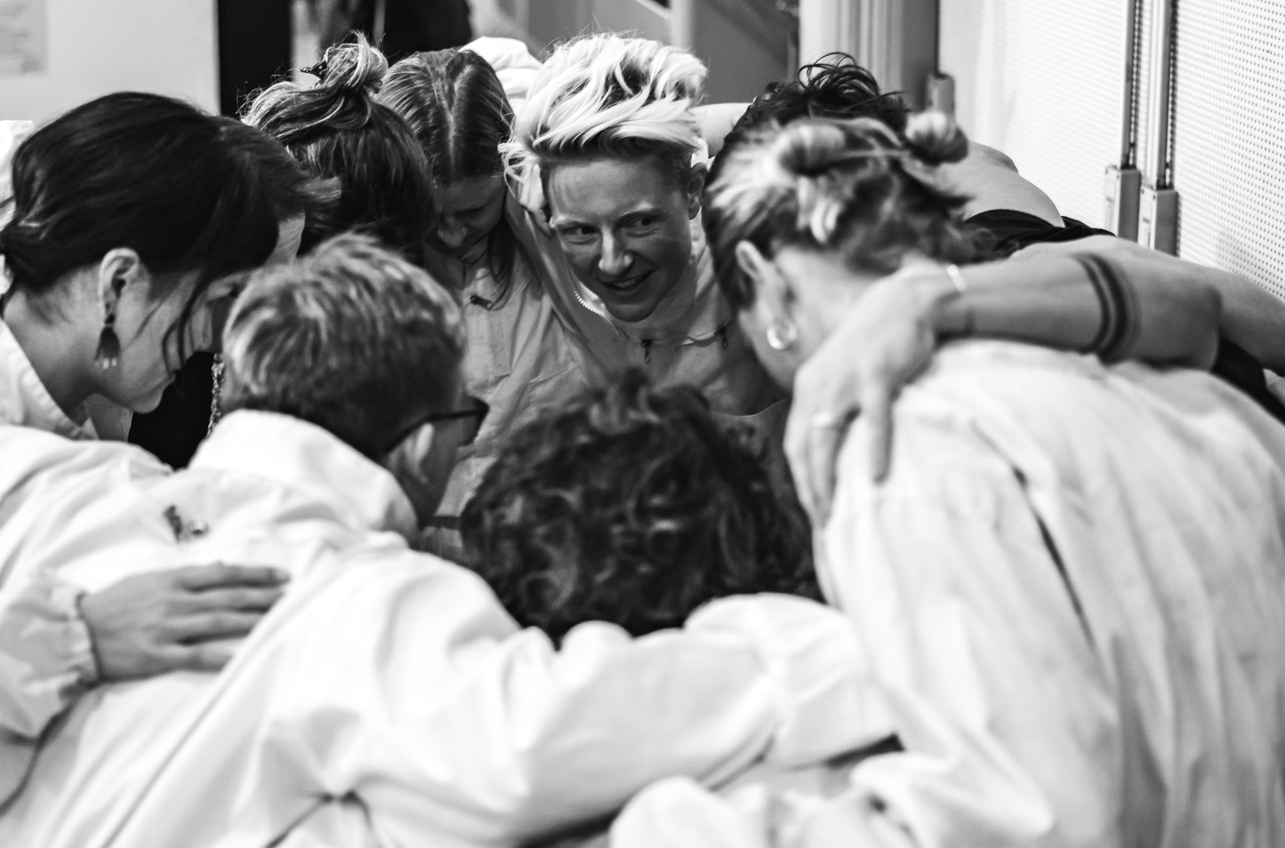

Image Credit: Second Echo Ensemble preparing for the MARK performance ATC 2021, image by Andrew Wilson.

WHY ABILITY TO CREATE
For this exhibition program we hope to support:
- All-ability artists in performance and installation of art works and for them to be recognised within the broader arts community.
- Three professional arts practitioners to work in this sector and to dissolve the artistic barriers between those living with or without a disability.
- Organisations and individuals working with all-ability artists.
- All-ability artists to lead creative practice.

WHERE
The major exhibition will take place in the Town Hall, Hobart. The other arts related workshop activities may take place at the various ATC organisations art spaces and in the arts practitioner’s studios where appropriate.

WHEN
TIMELINE 2024
- August – Confirm selected artists
- September - Induction and training sessions with Second Echo Ensemble
- Mid-September - Mentor artists to build a workshop program with ATC lead creatives
- September to November – Workshop Series #1 with mentor artists and ATC artists to build concepts and start on artwork
- 3rd December – Showcase Event – International Day People with Disability (IDPwD)

TIMELINE 2025
- February – Touch base re timelines
- March to June – Workshop Series #2 and completion of artworks co-created with mentor artists
- End June – Finalise all exhibition preparations and access features
- Tues 22 and Wed 23 July – Bump in
- 24, 25, 26, 28th July - Exhibition
- 29 July - Bump Out
- August – reflections and feedback about exhibition

WHO CAN APPLY?
We welcome applications from all arts practitioners as we wish to build capacity for artists who haven’t previously worked with a diverse group of all-ability artists. We also wish to increase workshop skills in artists working in community arts engagement.
City of Hobart employees cannot apply for this project.

BUDGET
Each arts practitioner will receive $7200 in total (GST Inclusive). This will include:
- SEE mentor training
- Workshop Series #1 prep and delivery x 3 workshops in Oct/Nov
- 3rd Dec 2024 IDPwD performative event + workshops/support
- Workshop Series #2 prep and delivery x 3 workshops in March/June
- Exhibition bump in/out and invigilation/workshop activity
- There may be a requirement from some/all of the artists to do additional community engagement workshops with the assistance of CoH staff, with extra workshop fees provided TBC.
We also have some extra funds for arts materials. Creative Hobart has equipment such as projectors, media players and speakers which can be used for the exhibition program if available.
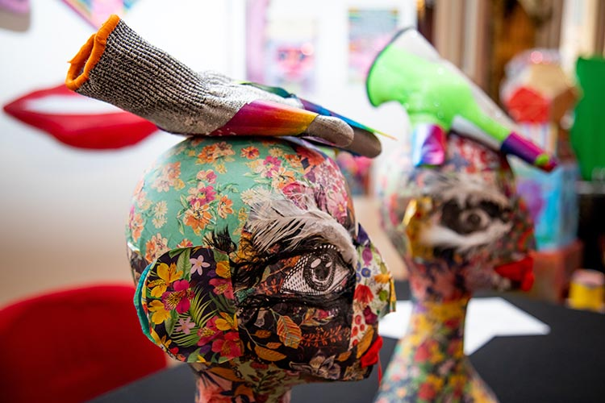

Image Credit: Just the Family 2022 - created by Freddy Lee Mount

WORKING WITH VULNERABLE PEOPLE (WWVP)
All successful applicants must have a current WWVP card and will need to obtain or show evidence of this before commencement of the project.

SUPPORT
The City of Hobart’s Cultural Development Coordinator, Sue Hayes, in collaboration with the Accessible City Coordinator Megan Cunningham, will offer assistance to all artists selected for the duration of this project.
We will also assist in connecting arts practitioners with the ATC artists and organisations in developing the work for the exhibition.

WHAT TO SUBMIT
Interested arts practitioners are asked to submit the following for consideration for selection:
- Artist EOI form, which includes identifying your skills against listed criteria, all relevant contact details, a maximum 250-word statement on your artist proposal for the project detailing how you would approach this opportunity, a workshop proposal and a short statement about your capacity to deliver the project.
- Portfolio of 3 pieces of work that you have completed that show your experience and capacity to complete the desired outcomes for this project.
- Curriculum Vitae (maximum 2 pages).

SELECTION
SUBMISSIONS WILL BE ASSESSED AGAINST THE FOLLOWING CRITERIA:
- Strength of approach in relation to the aims and theme of the project as stated in the “what we are looking for” section.
- Skills and experience to do the project.
- Strength and relevance of past work relevant to this project.

Selection of the three arts practitioners will be undertaken by the City of Hobart with an Advisory Panel consisting of at least 2 external members relevant to this project.
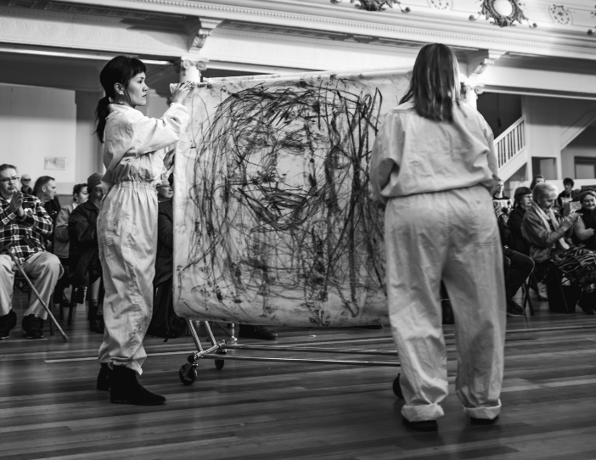

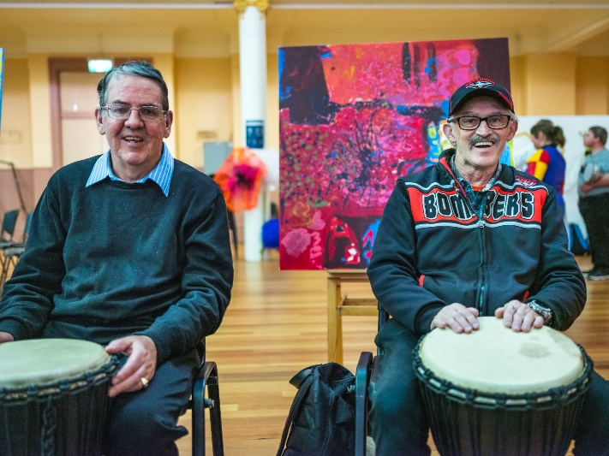

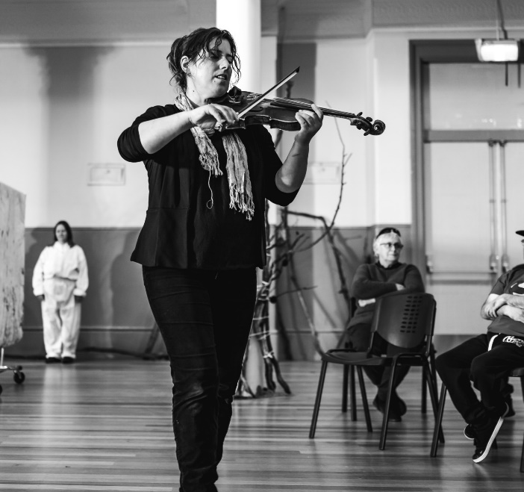

Image Credit: Second Echo Ensemble and other ATC artists in the City Hall, showing live performance, drumming and music. Images by Andrew Wilson ATC 2021.

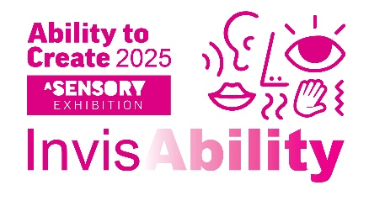

CONSIDERATIONS
The following practical aspects need to be considered in relation to the implementation of your project:
The artworks/activity must adhere to the theme of INVISABILITY: Making the invisible visible and incorporate a ‘sensory/interactive’ component.
- The artwork/activity must be:
- Inclusive - Everyone to feel welcome, valued and heard and have the opportunity to participate.
- Accessible - Everyone can get where they want to go with ease and can access the information they need to participate fully in the event.
- Interactive - The artwork/activity must aim to be as interactive as possible.
- Large Scale
- Safe - Everyone feels safe and secure and the artwork/activity must adhere to hygiene safe practices. The work also needs to be structurally safe for public accessibility and viewing.

RESOURCES
Below are a series of documents that guide the City of Hobart’s strategic vision around creativity and accessibility. We have also included a link to the Ability to Create webpage to view the July 2022 exhibition images and information including descriptions of the artwork.
Ability to Create Exhibition Creative Hobart Strategy
Community Inclusion and Equity Framework Capital-City-Strategic-Plan-2019-2029

CONTACT
If you have any questions, please call/email:
Cultural Development Coordinator Sue Hayes 6238 2823 hayess@hobartcity.com.au or
Accessible City Coordinator Megan Cunningham 6238 2431 cunninghamm@hobartcity.com.au

SUBMISSION DATE
Submit the completed EOI to Sue Hayes
hayess@hobartcity.com.au by 3pm Friday 9 August 2024
*Late submissions will not be accepted.
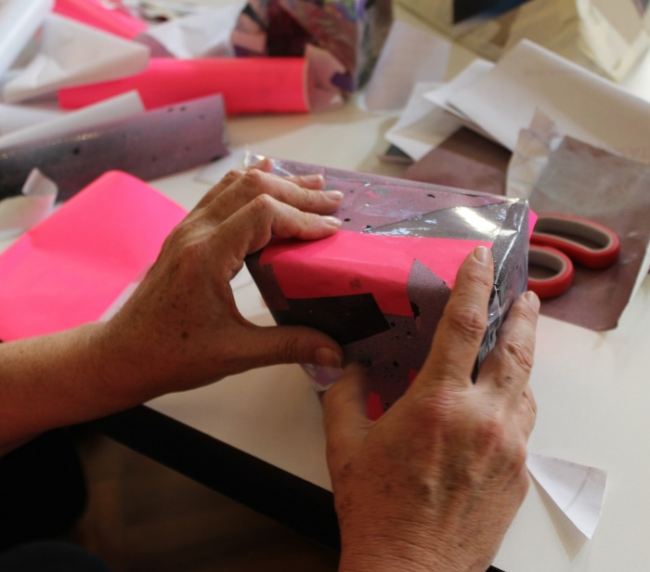

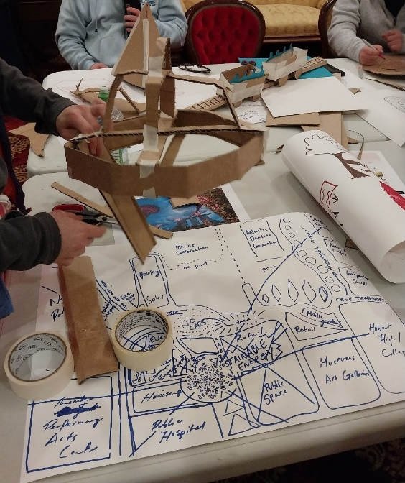

Image Credit: Workshop activities with ATC

artists and mentors, for ATC 2023

